Office Address:  705 Chatham Street  Sanford, NC 27330  919-776-8474  sanfordomi@gmail.com  Board Members:  Earl Murphy  Hamer Carter  Jayne Holland  Jenny Cabrera  Jimmy Holder  Laura Spivey  Mandy Moss  Neil Coggins  Sam Parker  Steven Hill  Tim Burriss  Todd Schooley  Ambassador:  Claire Hunt  Marcia Johnson  Ex-Officio:  Ken Smith  OMI has projects that need volunteers. To volunteer for projects  Go to:  volunteerunited.net  OMI Client Services  Totals – Qtr. -2021  Totals:  Clients Served 88  Men 49  Women &  Children 39  Veterans 1  Exits w/Employment 14  Exits w/Housing 27  Program Bed Nights  Men 741  Women 246  Lottery Bed Nights  Men 73  Women 50  Entry Bed Nights  Men 0  Women 6  Hotel Stay Nights 0  Total Bed Nights--1116  Meals Provided  Men 2442  Women 906  Total Meals 3348  Referrals  Job 116  Housing 31  DMV 28  Medical 58  Substance 22  Mental Health 46  Social Services 53  Whites 39  Black 44  Hispanic 5  Other 0  Total 88  Bible Study Groups  Groups from a local church are conducting Bible Studies at both the men's and women's shelters weekly for Clients who are interested in attending. Several residents in the homes have enjoyed this time of study and fellowship. Currently the women's study is on Sundays at 5:30 PM and the men's shelter is on Thursdays at 6 PM.  LEE County PIT Count  51 in Emergency Shelters  15 in Transitional Housing  91 Unsheltered  Total = 157  HOMELESS IN AMERICA = 567,715  COVID DEATHS =  548,162  <-> <-> <-> <-> <-> <-> <->  North Carolina Housing Coalition (NCHC) reports  On March 30, Governor Roy Cooper issued Executive Order #206, extending the state’s protections against eviction until June 30th, in line with the CDC’s recent extension of the national eviction moratorium.  <-> <-> <-> <-> <-> <-> <->  "For there will never cease to be poor in the land. Therefore, I command you, you shall open wide your hand to your brother, to the needy and to the poor, in your land."  Deuteronomy 15:11  Editors:  Marcia Johnson  Tim Burriss  Joy Murphy  Claire Hunt  Lillian Hatton | 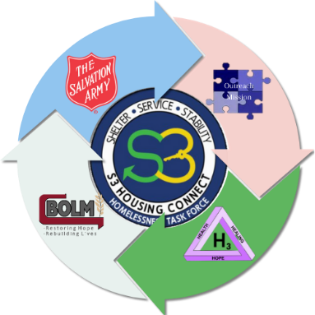  S3 Housing Connect Task Force of Sanford  fosters/nurtures/advances significant expansion project  Release Date: February 19, 2021 FOR IMMEDIATE RELEASE submitted by: Cindy Hall, Chair of S3 Outreach and Engagement Committee  S3 partners receive $202,000 to provide relief to those experiencing homelessness.  Last week four S3 partners received $202,000 from the State of North Carolina to provide relief to those experiencing homelessness in Lee County. Outreach Mission Inc., the Salvation Army, Bread of Life Ministry, and H3 (a street medicine program) will each benefit from this funding. All of them will better be able to meet the needs of those who are homeless in the local Sanford, NC area.  OMI will serve as the lead agency and fiscal agent for the funding. Hamer Carter, the Executive Director said, “We are excited to be taking the lead with this unique partnership. It is something new that we need to try. We believe that it will pay off for those who need shelter and a place to get back on their feet while they find a permanent home.”  Cindy Hall is assisting in the H3 street outreach with her husband, Dr. “Bill” Hall. According to Cindy, “This is such a blessing for our community and the people we see who are in need. We appreciate the City of Sanford’s commitment to building this partnership. It has paid off. Their financial support for helping us work together and build our capacity resulted in this award.”  Additional information following the press release…  From this funding, H3 will receive a mobile diagnostic analytic tool and a mobile van that will be outfitted for medical consultations. BOLM will receive funding for staffing for the adverse weather shelter. Salvation Army will receive funding for two fulltime positions for the day center. OMI plans to spread street outreach out into the county. $202,000 was received for all of those efforts, but much more funding is needed for each organization to continue its regular programs. Another press release will be put out so the general public understands that more money is needed to make these initiatives successful.  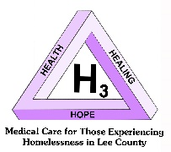  Dr. Hall – H3 Medical Street Outreach  Dr. William (Bill) Hall was inspired to begin his medical street outreach (H3) after reading an article in Reader’s Digest about a group of doctors in Boston who were motivated by the number of homeless needing medical attention. If they can do it, Dr. Hall said he would do it also, after he retired in the summer of 2017. So, after 11 years of medical practice in Minneapolis and 33 years in Sanford, he was going to use his God-given talents for the good of others. By January 2019, Dr. Hall realized he needed a headquarters type of place to better serve his clients. His friendships with John Pascal and Wayne Chew at Bread of Life offered that place. H3 represents Health, Healing and Hope.  Dr. Hall’s schedule (accompanied by wife Cindy) takes them out to the Prince and Palomino Motels, Depot Square and Mrs. Wenger’s where Life Springs Church serves a meal on Wednesdays, as well as at the Bread of Life. The settings are all outside in most elements of weather. Other scheduled days take Dr. Hall and Cindy to the Men’s and Women’s shelters and HAVEN (inside).  How does a primary care doctor administer testing and proceed to prescribe accordingly without the minimal medical tools and workspace? Within the financial benefits of the ESG CV funding, a handheld device – ISTAT - will be purchased. The ISTAT device checks electrolytes, blood sugar, and cholesterol. Another benefit of the ESG CV award will be the addition of the Navigation Center to be located at Bread of Life for Dr. Hall to have an indoor space to see patients. A dream for a later date is a van outfitted for his purpose. His work and care for those who suffer continues.  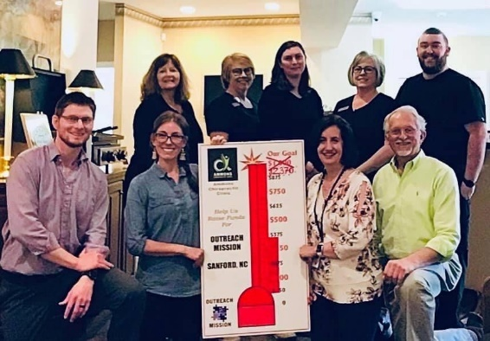The goal was $1,000. Amount donated was $2,370! This is the second year Ammons Chiropractic held a fundraiser for Outreach Mission. Laura Spivey, Vice President, gratefully received the donation as she is surrounded by the staff. OMI appreciates our local supporters!  A Note from the New Treasurer: Lillian Hatton  It has been just over a year since COVID-19 was declared a global pandemic and our lives changed. With no prior experience and limited guidance, the Board of Directors jumped headfirst into preparing and executing safety protocols that prevented both the men’s and women’s shelters from experiencing a single COVID-19 outbreak throughout the year. Wow! OMI has a very hard-working Board of Directors and Staff; however, we would not have been able to do any of it without the unwavering support from our community.  Even during a pandemic, Outreach Mission Inc. logged over 5,372 volunteer hours in the year 2020, which is worth $125,456.74 according to the federal government, and so much more to the individuals and families we help put their lives back together one piece at a time! Additionally, we have received a tremendous response from our monetary and in-kind donors. Our monthly contributors, including both the local church groups and private donors, help us keep the doors open and provide quality service to all those needing a hand-up! We would like to give a special thanks to Ammons Chiropractic, who’s first quarter fundraising totaled $2,370! We would also like to thank the generous organizations that provide donations of food and supplies as well as spiritual support, like weekly Bible study sessions.  In 2021, we will be focusing on exploring funding options to build a new homeless shelter that will house men, women, children, and families. This has been a big dream for Outreach Mission Inc., but we are finally seeing it come together because of your generous donations. In addition to securing the funds needed to complete the shelter, we will be working to support other nonprofit organizations in the county. As many of you may know, Outreach Mission Inc. has partnered with S3 Housing Connect, H3 – Health, Healing, Hope, Salvation Army, and Bread of Life Ministries to streamline and expand services to the homeless population in Lee County. We are grateful to have received some grant funds to kickstart this effort, but we need your help to continue to support these organizations. Thanks to all of you, our projected sustainability far surpasses our last evaluation, so let’s keep it going!  Become a friend of the mission by visiting our website. www.sanfordomi.com  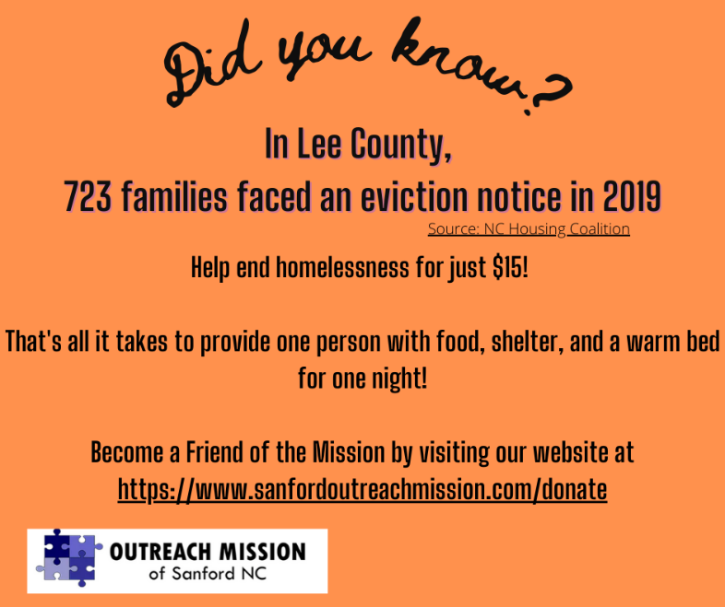  Employee Recognition  ~ Paul Tate ~  “Director of Client Services” - The title sounds daunting and formidable, doesn’t it? As the newly promoted Director of Client Services (DCS), Paul Tate, began speaking about his present position, his eyes lit up and became warm and understanding, as his whole being became energized and animated. He began to reel off the duties and responsibilities of the position, AND there are many. They are: being responsible for day-to-day activities for both the women’s and men’s houses; AND supervising full staff. This presently entails two case managers, one housing specialist, one intake specialist, and three house supervisors. When the system is fully staffed, we are looking at potentially ten staff members. At this point, staff will be poised to slide into the proposed new shelter. In addition to these tasks, he can and will use his title to help other resources work together to help end this homelessness beast.  Paul shared the reasons how and why he is fully convicted to offer help and guidance to those that are facing struggles. He has experienced the immense agony that people battling drugs, alcohol, and homelessness and their families are buried within. He was called to make a difference in the lives of people that are facing struggles when he watched his younger brother’s life be engulfed by alcohol. Paul said he saw his brother go through all the stages of alcoholism. His brother passed from this life while in Paul’s lap. He knew THEN this was his calling. His goal is to help everyone that Jesus puts in front of him.  What happens to put people in positions of homelessness??? Stories and barriers are myriad. Paul is ready and willing to seek out and utilize the multitude of services and resources to assist those that are struggling.  The newly appointed DCS says being able to rejoin a person that is experiencing homelessness with family or to help them move into a permanent home is like receiving an incredible Christmas gift that’s all for your soul.  Paul chose a recent Saturday to do his own ad hoc survey of the homeless. The results were: he found 32 people sleeping in cars and under bridges. What a heart wrenching discovery! Paul said, “You repair as much as possible!”.  This led to the revealing of the fact Paul is anticipating the beginnings of a street ministry. He says the potential to help thrills him. He embraces the opportunity to reach as many people as possible. He also realizes ALL THE PIECES OF THE PUZZLE have to be present to make this incredible task a reality. Can you be a part of the puzzle? Would you volunteer time or donate funds?

Church Supporters
Buffalo Presbyterian Cool Springs Baptist Edgewood Presbyterian Women First Baptist
First Calvary Baptist First Presbyterian Jonesboro Heights Baptist Jonesboro UMC
Lemon Springs UMC Life Springs Macedonia AME Zion New Zion Baptist
Pocket Presbyterian San Lee Chapel Shallow Well UCC St. Luke UMC
St. Stephen Catholic St. Thomas Episcopal Swann Station Baptist Turners Chapel
Union Grove Chapel Zion Christian

Partner Agencies
Bread of Life Ministries Brick Capital Day-Mark Recovery
Divine Finds Enrichment Center of Lee County Family Promise
H3 - Health, Healing, Hope HAVEN of Lee County Helping Hand Clinic
NC Works Partners for Children & Families Reach Out Crisis Pregnancy Center
Ray’s Appliances Salvation Army Sanford Job Seekers
Total Package

Business Supporters

Disclaimer: Any omissions or errors can be reported to the Editors. | To remove you name or correct information, contact OMI via email or by phone.

